Dashboard Design

Date | 22 September 2026
Team ID
Project Name | Comprehensive Analysis of Online Learning Engagement and Student Performance
Maximum Marks | 5 Marks

Creating an effective dashboard involves thoughtful design to ensure that the presented information is clear, relevant, and easily understandable for the intended audience. Here are some key principles and best practices for dashboard design

Activity 1: Interactive and visually appealing dashboards
Creating interactive and visually appealing dashboards involves a combination of thoughtful design, effective use of visual elements, and the incorporation of interactive features.

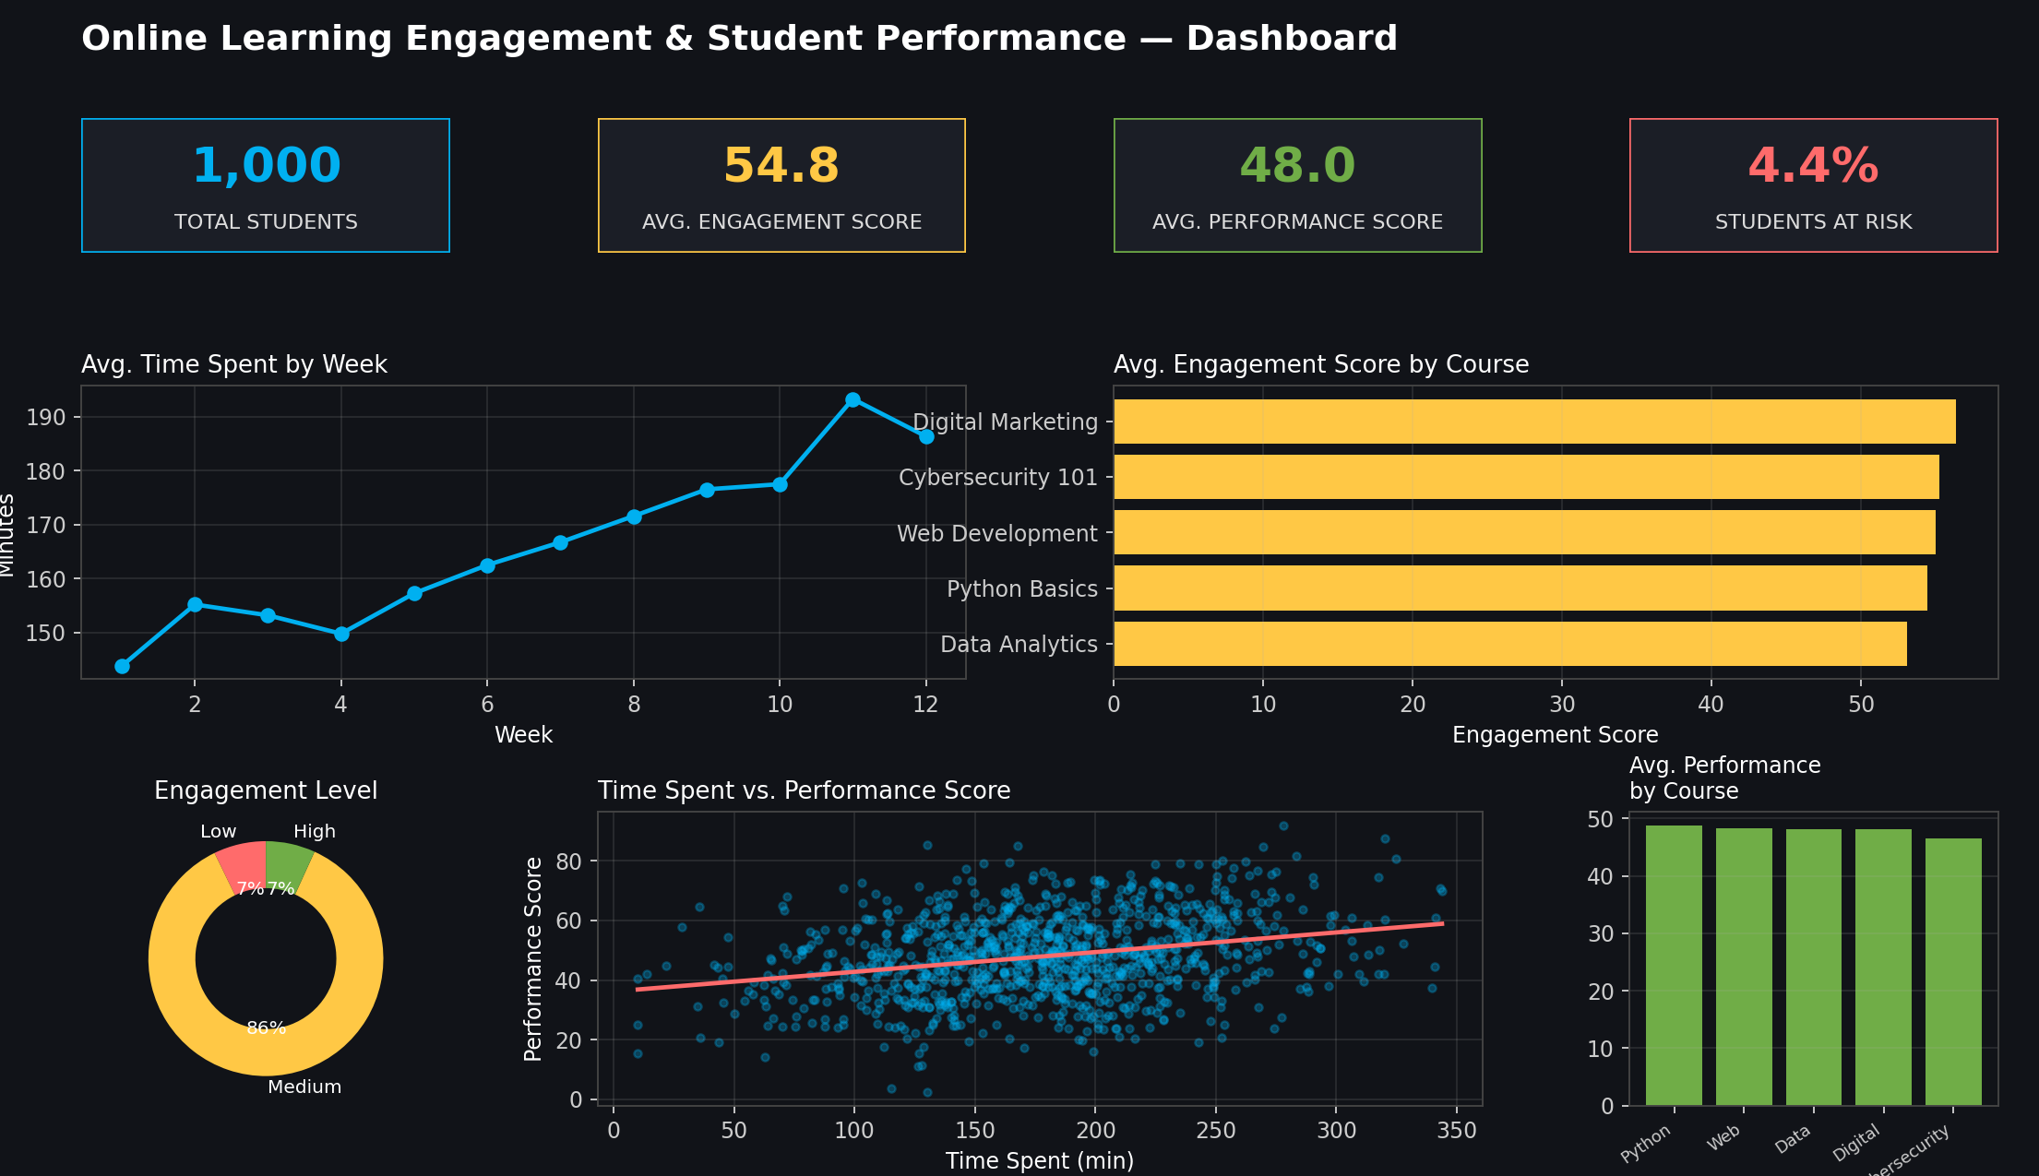

Here are six key outcomes from the dashboard shown above:

- Total Students Tracked: The dashboard covers 1,000 students across 5 courses, giving a broad and representative view of engagement and performance.

- Average Engagement Score: The overall average Engagement Score is 54.8 (out of 100), indicating most students are moderately engaged with course content.

- Average Performance Score: The average Final Performance Score across all students is 48.0, showing room for improvement in overall academic outcomes.

- Students At Risk: 4.4% of students fall into the at-risk category (low engagement combined with low performance), flagging a small but important group for early intervention.

- Course-Level Engagement: Digital Marketing has the highest average engagement score (56.3), while Data Analytics has the lowest, suggesting course design differences worth investigating.

- Time Spent vs. Performance: The scatter plot shows a positive relationship between time spent and performance score — students who spend more time on the platform tend to score higher, though with notable spread.

